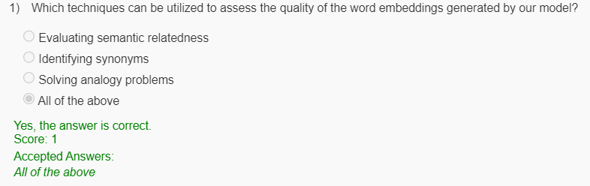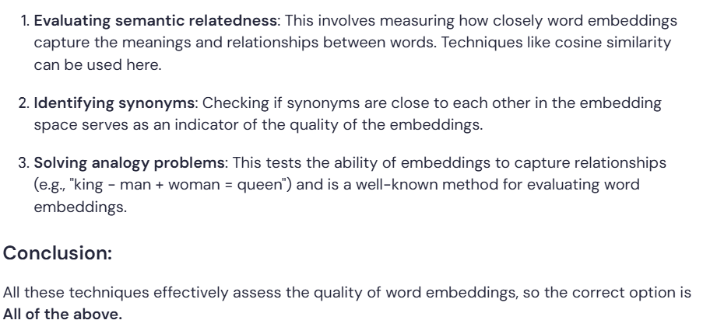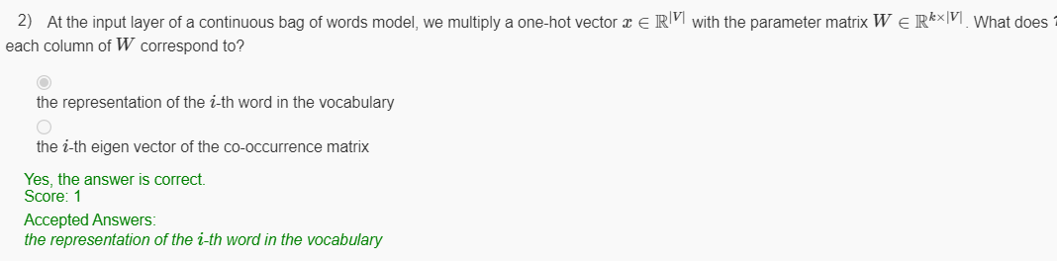

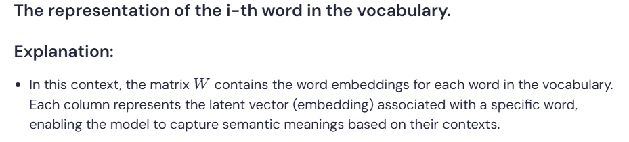

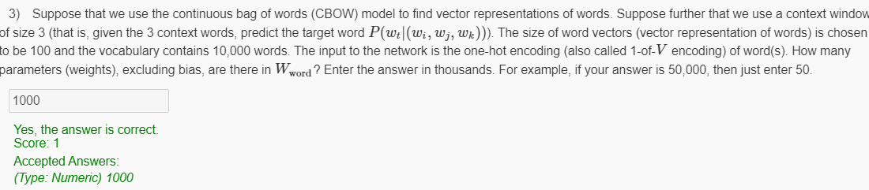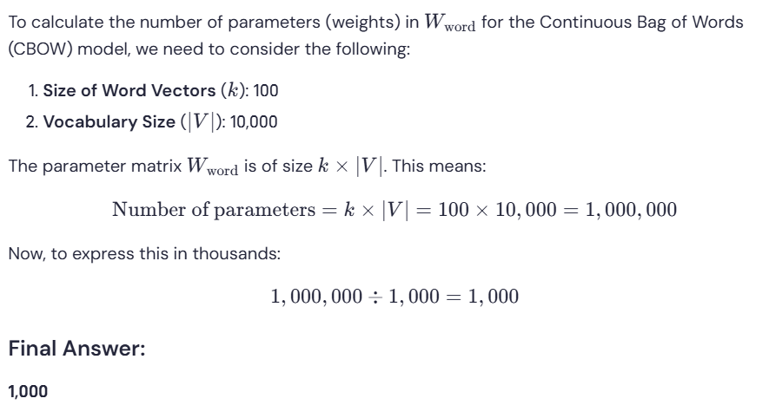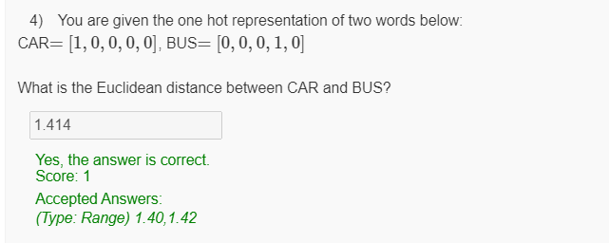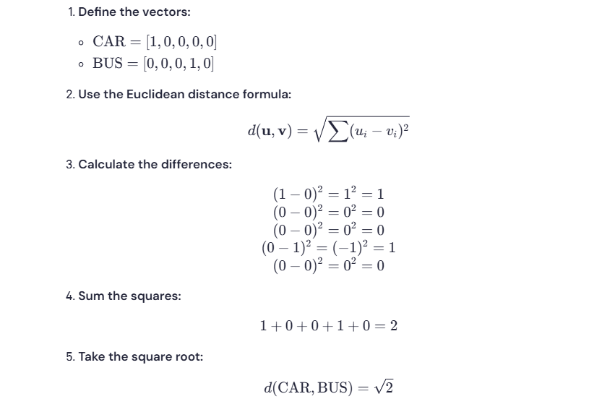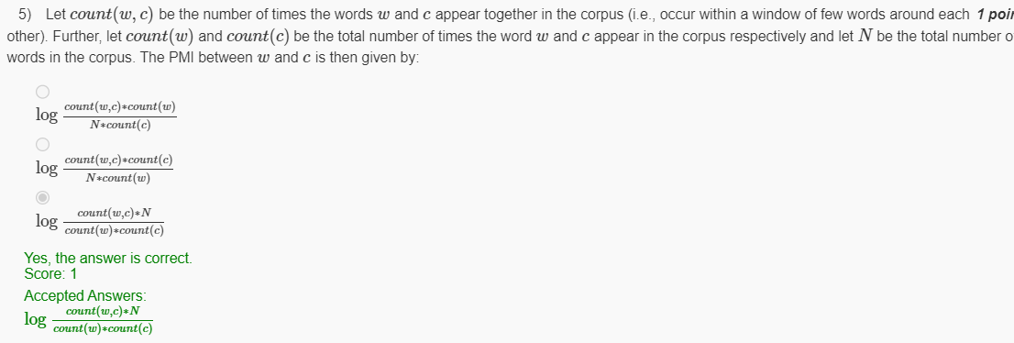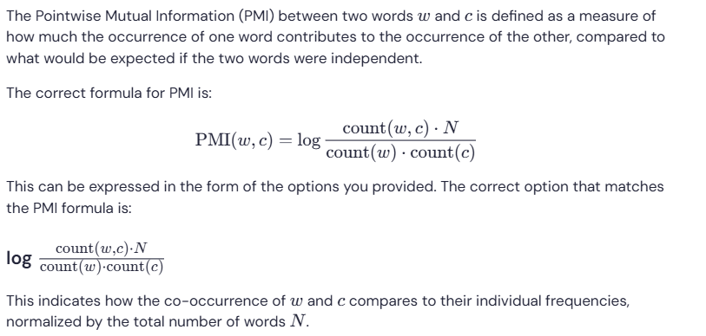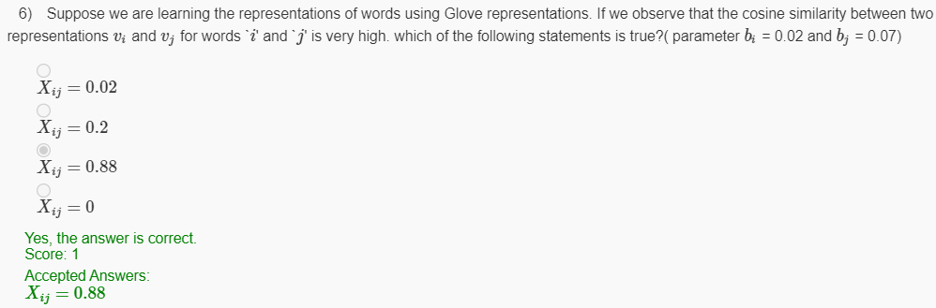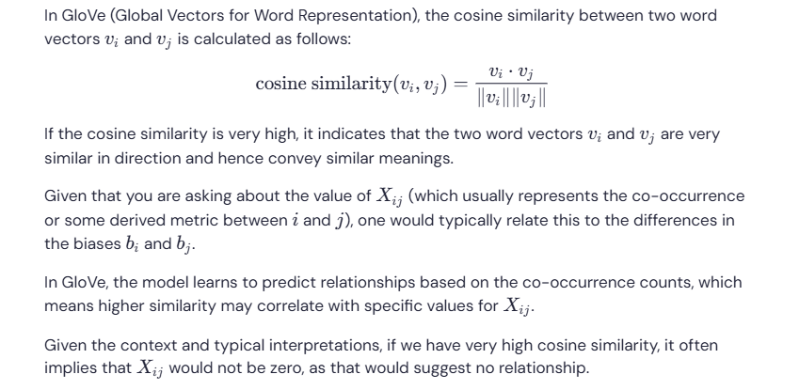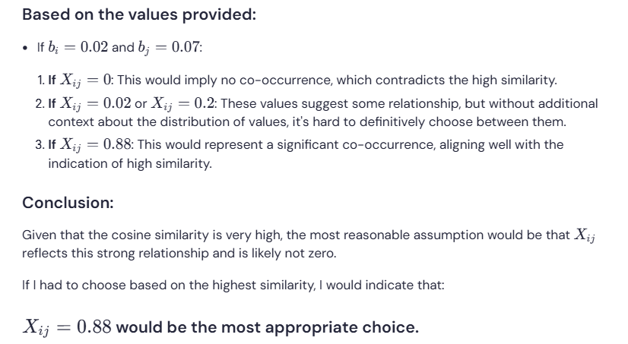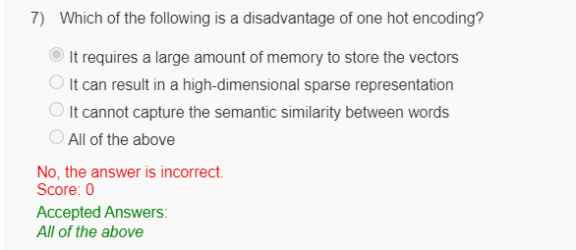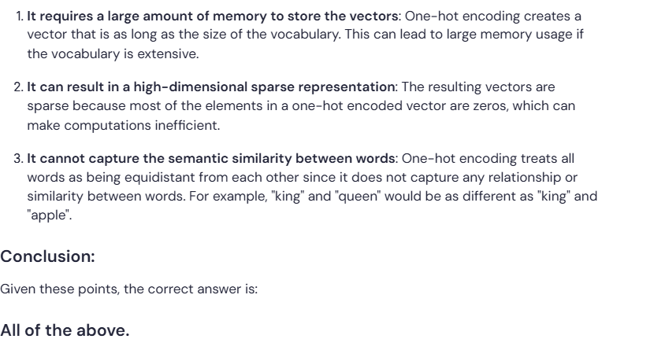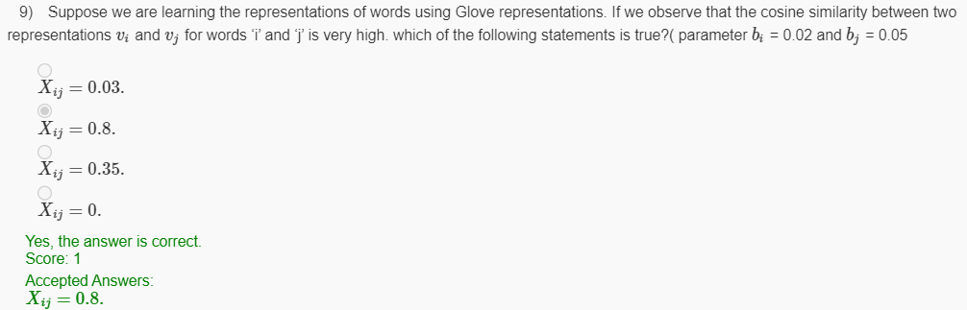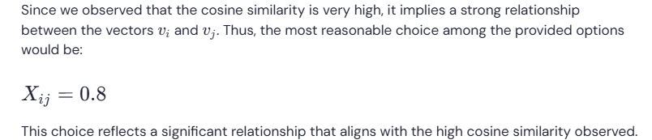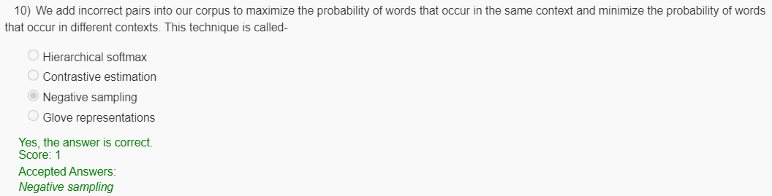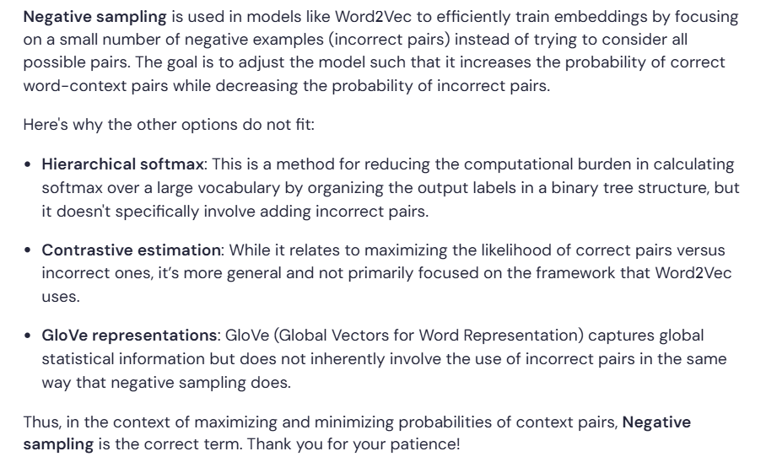

**Question 8:**

Which of the following is an advantage of using the skip-gram method over the bag-of-words approach?

* The skip-gram method is faster to train
* **The skip-gram method performs better on rare words**
* The bag-of-words approach is more accurate
* The bag-of-words approach is better for short texts

**Question 9:**

What is the computational complexity of computing the softmax function in the output layer of a neural network?

* **O(n)**
* O(n²)
* O(nlogn)
* O(logn)

**Question 10:**

How does Hierarchical Softmax reduce the computational complexity of computing the softmax function?

* It replaces the softmax function with a linear function
* **It uses a binary tree to approximate the softmax function**
* It uses a heuristic to compute the softmax function faster
* It does not reduce the computational complexity of computing the softmax function